
Electronic Circuits 1

P2024
Jassar, Surinder
3
Bridge Rectifier
May 24, 2024
May 24, 2024
Mourad Shai
04
501170415
Sharma
Tanishq
501122854
04
TS
Table of Content
1. Introduction...........................................................................................R2
2. Objectives..............................................................................................R2
3. Circuit under Test..................................................................................R2
4. Experimental Results............................................................................R5
5. Conclusions and Remarks.....................................................................R6
6. Appendix: Signed Pre-Lab and TA Copy of Results...............................R9

Introduction:
The report for Lab 3, bridge rectifiers, is shown below. The lab took place on May 21st, 2024. The signed-off pre-lab and the TA copy for experimental results are placed at the end as an Appendix.

Objectives:
The goal of this lab was to explore and study bridge rectifiers. Since diodes permit current to flow in only one direction, rectifiers can be used to convert AC to DC. The circuit outlined in the lab manual was constructed, and results were obtained using an oscilloscope, voltage source, and ammeter.

Circuit Under Test:
Figure 1 illustrates a bridge rectifier connected to a resistive load. The voltage across the load resistor (Vo) and the input voltage (Vi), which is the voltage between the positive and negative terminals of the signal generator, can be measured using an oscilloscope.
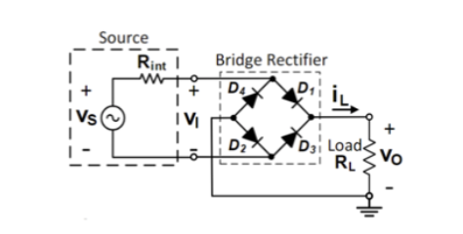
Figure 1: Bridge Rectifier with a Resistive Load

Figure 2 depicts the same circuit as in Figure 1, but with the negative terminal of the signal generator connected to the ground. The output and input voltages are measured in the same manner as described previously.
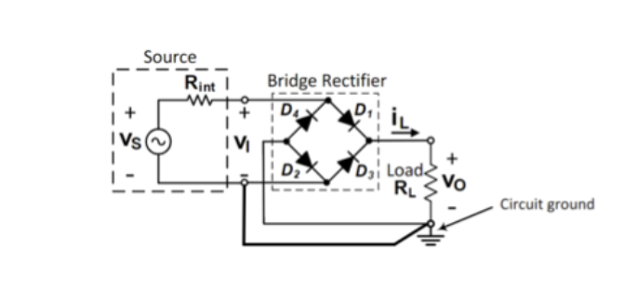
Figure 2: Bridge Rectifier with Grounded Signal Generator

Figure 3 shows a rectifier constructed using four red light-emitting diodes (LEDs) connected in series with a green LED and a 1kΩ resistor. The signal generator is configured to produce a sinusoidal signal with a frequency of 0.5 Hz. The blinking LEDs demonstrate the rectifier's operation.
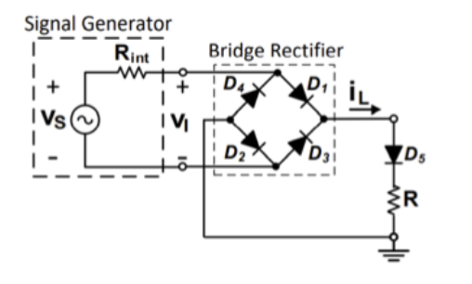
Figure 3: Bridge Rectifier using LEDs

Figure 4 displays a rectifier built with four 1N4148 diodes connected in series with an R_{L} load. The output voltage waveform (Vo) is recorded over approximately three cycles using two oscilloscope probes. The oscilloscope is set to Math mode, with the output voltage measured by subtracting the signal of channel two from channel one. Both channels are in DC coupling mode, have identical voltage per division settings, and use the same signal attenuation on their probes. The signal generator is set to produce a symmetrical sinusoidal waveform with a frequency of 500 Hz and an amplitude of 16 V peak-to-peak.

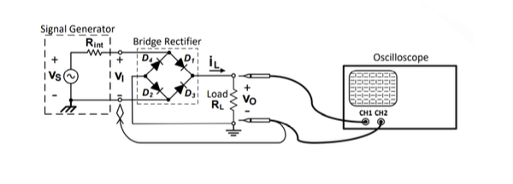
Figure 4: Bridge Rectifier with 1N4148 Diodes and R_{L}​ Load

Figure 5 illustrates a rectifier built using four 1N4148 diodes connected in parallel with a 1F polyester capacitor and an R_{L} load. The oscilloscope captures the output voltage waveform (Vo) over approximately three cycles. The ripple voltage is measured by capturing the fluctuating component of Vo, achieved by setting the input channels to AC mode and gradually increasing the voltage per division setting. A bench-top multimeter is used to measure the DC output voltage.
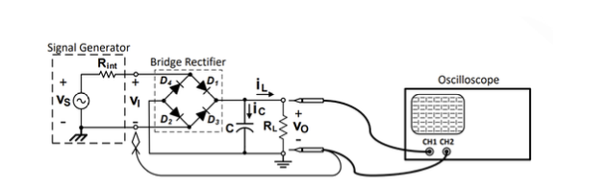
Figure 5: Bridge Rectifier with Capacitor and R_{L} Load
Experimental Results:
Observations (E1)

Diode D1 blinked in an opposite pattern to Diode D4, meaning when one was on, the other was off. Diodes D2 and D3 did not turn on at all. Diode D5 blinked at the same time and followed the same pattern as D1. The red LEDs began blinking at lower voltages, with D4 starting at approximately 2.0V and D1 at 4.5V. The green LED started blinking only after the voltage reached 5.5V.

Observations (E2)
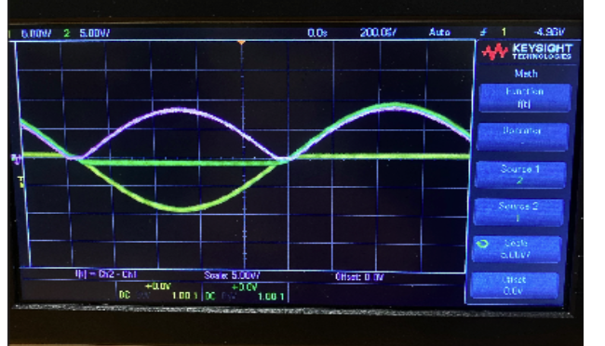
Observations (E3)

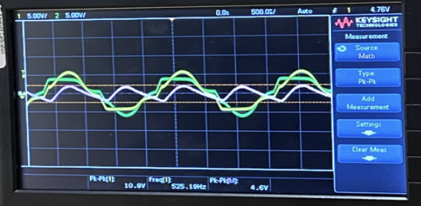

__  V_{o} [V] | V_{R} [V]
5.40 | 1.80
Table E3: DC output voltage and peak-to-peak ripple:
Conclusions and Remarks:
C1:
The waveform that most accurately depicts the manually-derived transfer characteristics of a bridge rectifier is Graph P2(a). This choice is based on its amplitude, which closely aligns with the observed 6.5V amplitude on the manually-drawn graph. In contrast, Graph P2(b) exhibits a slightly lower amplitude. The discrepancy between the two graphs stems from the resistance value incorporated into the circuit. Typically, circuit components possess internal resistance, influencing the actual numerical outcomes as opposed to theoretical calculations, which presume ideal wires and components with precise resistance values.

C2:
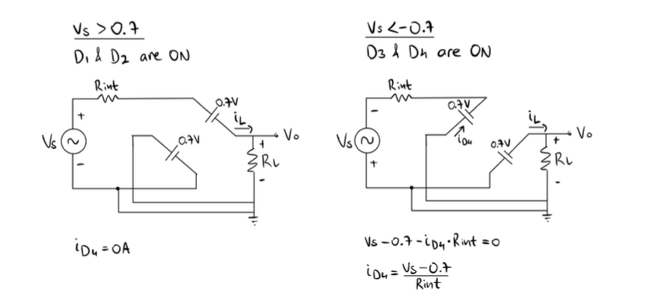
Figure 6: Solution for C2

Referring to Graph P3, it's evident that iD4 remains at 0A when the source voltage exceeds 0.7V. Furthermore, iD4 reaches -300mA at its maximum negative voltage. The direct connection between the circuit ground and the negative source terminal in the bridge rectifier restricts the input voltage predominantly to positive values. Consequently, the output voltage remains within the positive range, causing the current through D4 to be negative. If the source were to supply excessive current, it could potentially lead to diode burnout and failure.

C3:
During this step, the blinking frequencies of the red LEDs mirrored the frequency of the voltage source. As the AC source alternated between negative and positive, D3 and D4 illuminated when the voltage was negative, while D1 and D2 remained reverse-biased. Conversely, a positive voltage source forward-biased D1 and D2 while keeping D3 and D4 off. Thus, each set of LEDs remained illuminated per cycle. Since DC voltage is consistently positive, D5’s forward-biased and lit continuously. The green LED reflected the frequency of the rectified voltage post-full wave rectification, which was double that of the red LEDs.

C4:
Graph P2(a) illustrates the behavior of a full-wave bridge rectifier, where the output voltage adheres to the relationship VO = |VI|. Conversely, Graph E2 depicts characteristics akin to a half-wave bridge rectifier, with the output voltage remaining zero during the negative phase of the input voltage cycle.
C5:
Both Graphs P4(a) and E3 exhibit similar trends, notably with the stair-like pattern in their rise and fall of Vo. Although the representations of Vi and Vs appear somewhat distorted, similar distortions were present in the simulated graphs albeit to a lesser extent. These distortions still align because adjusting the scale of the measured graphs would bring them closer to the simulated values. However, a comparison between Table P4 and the measured values reveals discrepancies. These discrepancies may be attributed to circuit noise, which interfered with the output signal, along with potential issues with weak connections or equipment malfunction. The calculated values for P4 were 6.34 V for Vo and 0.86 V for Vr, while the measured values were 5.8 V and 1.09 V respectively.
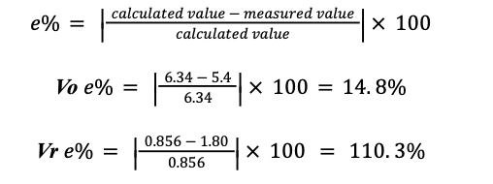
The higher-than-expected % error in both values can be attributed to the inaccuracies in the waveform produced by the oscilloscope, making it challenging to measure the average voltage and ripple voltage accurately.

C6:
The full-wave bridge rectifier effectively converts the alternating current (AC) signal from the source into a direct current (DC) signal, which remains within the positive voltage range albeit with some ripple. The inclusion of a smoothing capacitor further stabilizes the DC output voltage, increasing its average value. The choice of load resistor influences the stability of the DC output voltage, as expressed by the following relationship:
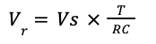

According to this formula, a higher load value results in a smaller ripple voltage and a more stable output voltage. Optimal performance was observed when using a 56kΩ resistor as the load. In this configuration, the resulting waveform appeared nearly linear over time at the maximum DC output voltage, with the highest average voltage achieved.

Comparatively, when a 5.6kΩ load was employed, the average DC output voltage decreased, accompanied by a higher ripple compared to the higher load scenario. Finally, employing the lowest load of 560Ω led to the largest ripple, the least stable DC output voltage, and the lowest average voltage among the three load scenarios.
Appendix: Signed Pre-Lab and TA Copy of Results
*PRE LAB INCLUDED SEPARATELY*



